New York Times Bestsellers Books and Movie

# Details description:

This skill provides information about bestsellers book listed on New York Times with latest data and also provides movie review summery and information link to get details of the movie review

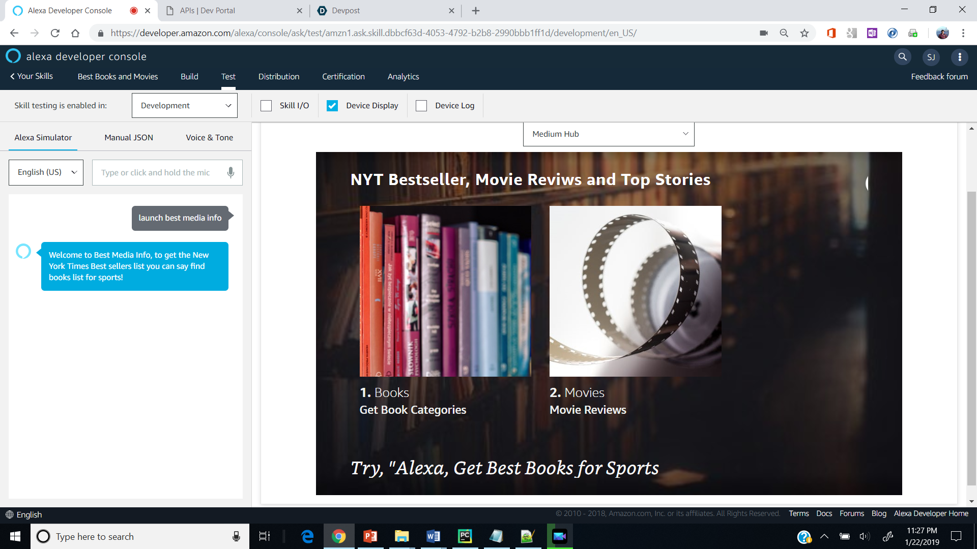

To start skill use invocation:

***"Alexa, Launch Best media info"***

Now the skill has two segments (1) Book Info (2) Movie Review

# (1) Book Info

(i) to get book categories please say

***"get categories",***

***"get book categories"***

(ii) To get bestsellers list for any category ask

***"get books for sports"***

***“get book for sports at rank one***

***“find book for travel at rank two***

***“get best book for science at rank three”***

# (2) Movie Review

To get movie review ask:

***“get movie review”***

***“find movie review”***

***“tell movie reviews”***

# (3) Support for display devices:

As you ask for book or moview, information is also displayed on the display of the device

The navigation is as follows:

# Home Screen :

1. Button for Books
2. Categories - > Click on any category - > Book List -> Click on a Book -> Individual Book Details will be displayed
3. Button for Movies
4. 5 movie items shall be displayed . On clicking any movie item , details of the movie shall be displayed.

# Navigate to Home screen :

1. By clicking on Logo of the screen
2. By saying “ Go Home”

All data is used using NYT API

**what's new**

Bestseller categories lists, for each category book list is provided

Movie review

1-Alexa, open best media info

2-Alexa, start best media info and get books for sports

3-Alexa, start best media info and get movie review

**Keywords**

Book, Movie, Review, bestsellers, new-york-times, education, sports, actor, news, information, topper, media, critics, weekly, chartbuster, hollywood, author, ISBN

Privacy Policy URL

<https://github.com/Kitemaker/The-Bestsellers/blob/master/terms.txt>

Terms of Use URL

<https://github.com/Kitemaker/The-Bestsellers/blob/master/terms.txt>

